Racerstar BR2212 1000KV 2-4S Brushless Motor
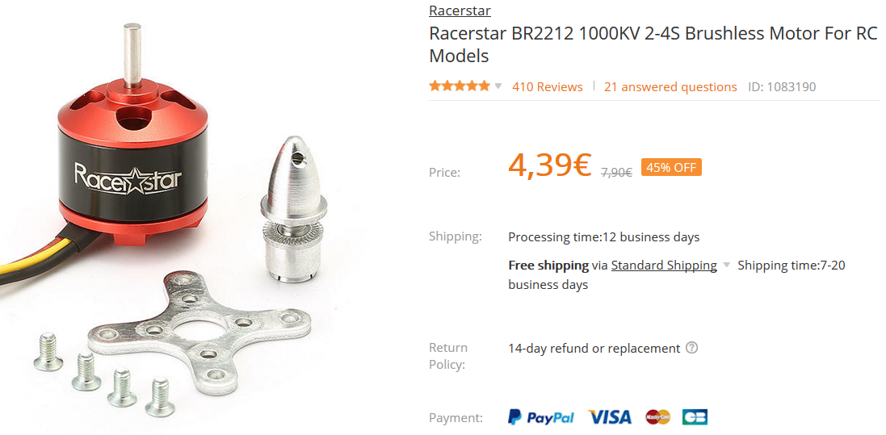
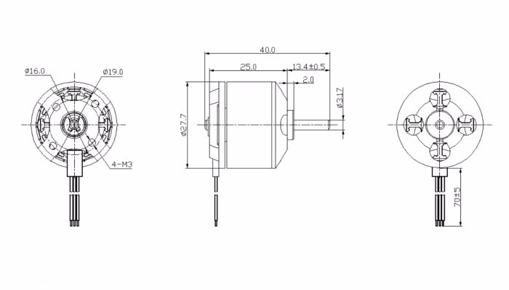
Description:
Brand Name: Racerstar
Item Name: BR2212 brushless motor
KV: 1000
Operating Voltage: 2-4S
Weight: 52g
Recommended Prop: 1047
Testing Data:
Model | Voltage | Prop | Load Current  (A) | Pull  (g) | Power  (W) | Efficiency  (g/w)
BR2212 1000KV | 11.1 | 1047 | 15.6 | 885 | 173 | 5.1
Package Included:
1x Racerstar BR2212 1000KV brushless motor
1x Accessories

