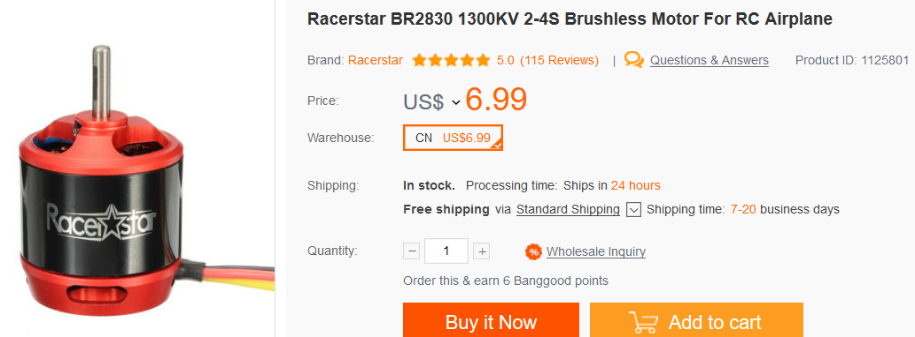
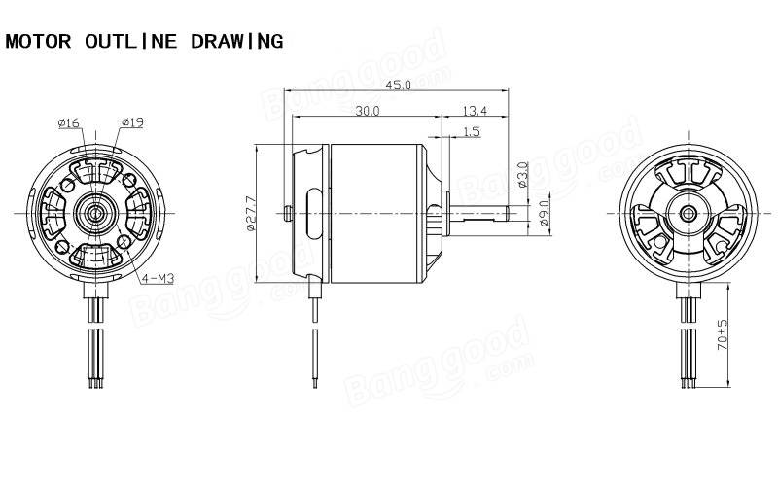
Description:
Brand Name: Racerstar
Item Name: BR2830 brushless motor
KV: 1300
Operating Voltage: 2-4S
Weight: 60.5g
Recommended Prop: 9050,1045
Testing Data:
Model | Voltage | Prop | Load Current  (A) | Pull  (g) | Power  (W) | Efficiency  (g/w)
BR2830 1300KV | 11.1 | 9050 | 21.5 | 1130 | 238 | 4.7
BR2830 1300KV | 14.8 | 1045 | 29.0 | 1310 | 429 | 3.1

